Dayananda Sagar College of Engineering
Department of Electronics and Communication Engineering

AAT2

Program: B.E. | Branch: ECE
Course: Digital Communication | Semester : 6th Semester
Course Code: EC61 | Date: 13/03/2018

A report on

“Uniform and Gaussian CDF & PDF plots in Matlab”

Submitted by

MD. SARFRAZ SIDDIQUI 1DS15EC067
NISHANT SAHAY 1DS15EC075
NRUSINGHA CHARAN 1DS15EC077
PRABHU SOLOMON 1DS15EC081

Under the guidance of

Prof. Rajanish N

Probability Density Function & Cumulative Density Functions of Uniform & Gaussian Distributions

THEORY
A random variable, random quantity, aleatory variable, or stochastic variable is a variable whose possible values are outcomes of a random phenomenon. As a function, a random variable is required to be measurable, which rules out certain pathological cases where the quantity which the random variable returns is infinitely sensitive to small changes in the outcome.
Cumulative Distribution Function
The cumulative distribution function (CDF, also cumulative density function) of a real-valued random variable X, or just distribution function of X, evaluated at x, is the probability that X will take a value less than or equal to x. In the case of a continuous distribution, it gives the area under the probability density function from minus infinity to x. Cumulative distribution functions are also used to specify the distribution of multivariate random variables.
Probability Density Function
A probability density function (PDF), or density of a continuous random variable, is a function, whose value at any given sample (or point) in the sample space (the set of possible values taken by the random variable) can be interpreted as providing a relative likelihood that the value of the random variable would equal that sample. In other words, while the absolute likelihood for a continuous random variable to take on any particular value is 0 (since there are an infinite set of possible values to begin with), the value of the PDF at two different samples can be used to infer, in any particular draw of the random variable, how much more likely it is that the random variable would equal one sample compared to the other sample.\
CDF & PDF of Uniform Distribution
The continuous uniform distribution or rectangular distribution is a family of symmetric probability distributions such that for each member of the family, all intervals of the same length on the distribution's support are equally probable. The support is defined by the two parameters, a and b, which are its minimum and maximum values.

The probability density function of the continuous uniform distribution is:
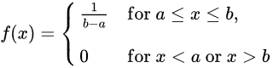

The cumulative distribution function is:
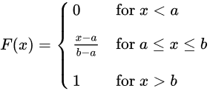
The values of f(x) at the two boundaries a and b are usually unimportant because they do not alter the values of the integrals of f(x) dx over any interval, nor of x f(x) dx or any higher moment. Sometimes they are chosen to be zero, and sometimes chosen to be 1/(b − a). The latter is appropriate in the context of estimation by the method of maximum likelihood. In the context of Fourier analysis, one may take the value of f(a) or f(b) to be 1/(2(b − a)), since then the inverse transform of many integral transforms of this uniform function will yield back the function itself, rather than a function which is equal "almost everywhere", i.e. except on a set of points with zero measure. Also, it is consistent with the sign function which has no such ambiguity.
The ideal graphs for uniform PDF & CDF are
CDF PDF
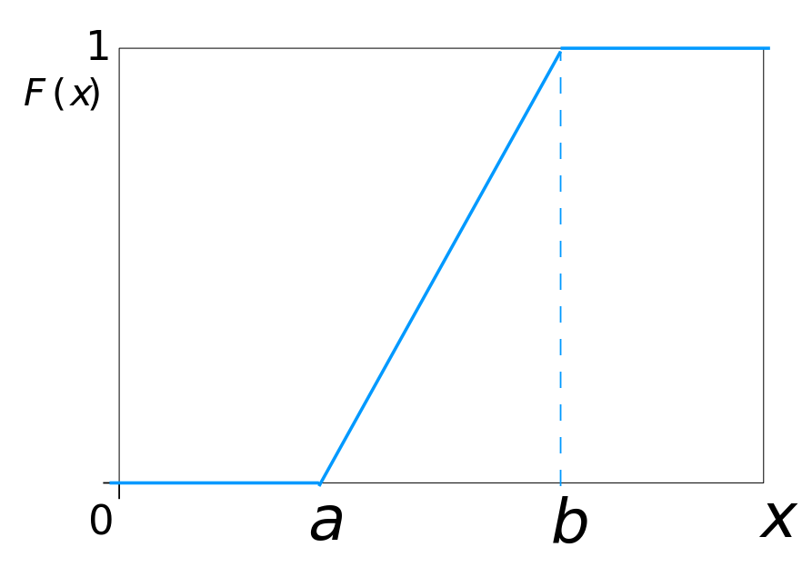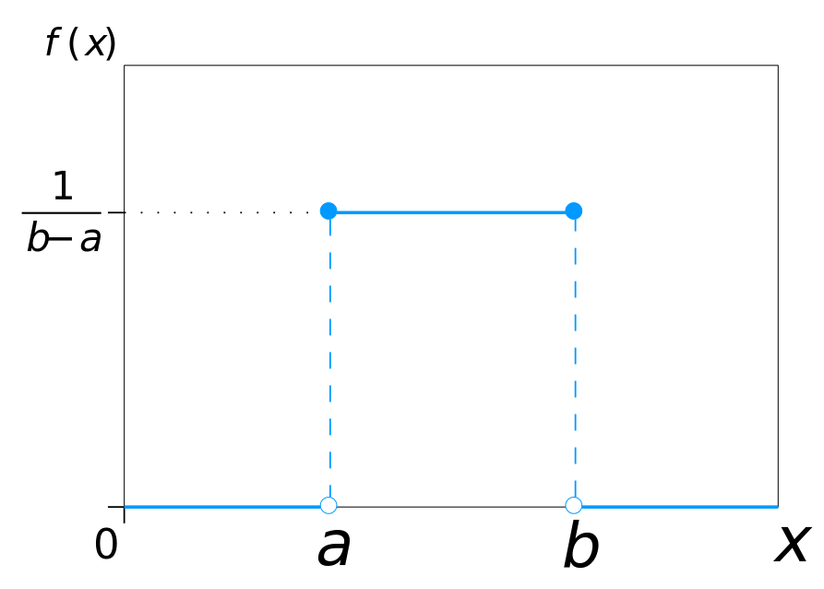

CDF & PDF of Gaussian/Normal Distribution
The normal (or Gaussian or Gauss or Laplace-Gauss) distribution is a very common continuous probability distribution. Normal distributions are important in statistics and are often used in the natural and social sciences to represent real-valued random variables whose distributions are not known.^{[1][2]} A random variable with a Gaussian distribution is said to be normally distributed and is called a normal deviate.
The normal distribution is useful because of the central limit theorem. In its most general form, under some conditions (which include finite variance), it states that averages of samples of observations of random variables independently drawn from independent distributions converge in distribution to the normal, that is, become normally distributed when the number of observations is sufficiently large. The normal distribution is sometimes informally called the bell curve
PDF
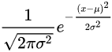
CDF
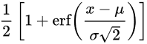
where
μ s the mean or expectation of the distribution (and also its median and mode),
σ is the standard deviation, and
σ ² is the variance.
CDF PDF
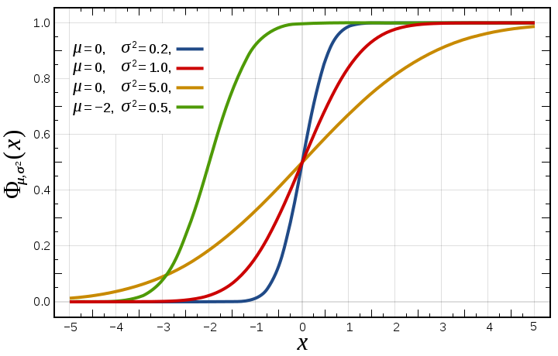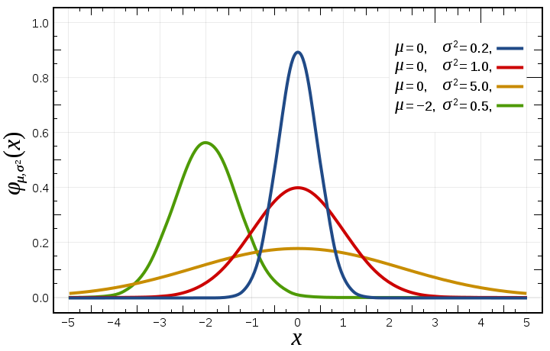

MATLAB CODE
Clear all;
clc;
close all;
variance=input('Enter the variance of the Normal PDF ');
means=input('Enter the mean of Normal PDF');
a=double(input('Enter the value of a of Uniform distribution'));
b=double(input('enter the value of b of Uniform distribution'));
x=-10:.01:10;
pdf_normal=exp(-0.5*((x-means).^2)/variance)/(sqrt(variance*2*pi));
syms x
t=int(exp(-0.5*((x-means).^2)/variance)/(sqrt(variance*2*pi)),x);
x=-10:.01:10;
cdf_int_normal=(subs(t));
%cdf_normal=0.5*(1+erf((x-means)/sqrt(2*variance)));
figure(1)
grid on
subplot(2,1,1),plot(x,pdf_normal),title('Normal or Gaussian PDF'),xlabel('X'),ylabel('PDF f(x)'),grid on
subplot(2,1,2),plot(x,cdf_int_normal),title('Normal or Gaussian CDF'),xlabel('X'),ylabel('CDF F(x)'),grid on

for i=1:2001
if(x(1,i)>=a) && (x(1,i)<=b)
pdf_uniform(1,i)=1/(b-a);
else
pdf_uniform(1,i)=0;
end
end

for i=1:2001

if(x(1,i)>=a) && (x(1,i)<=b)
cdf_uniform(1,i)=(x(1,i)-a)/(b-a);
elseif x(1,i)<a
cdf_uniform(1,i)=0;
else
cdf_uniform(1,i)=1;
end
end
figure(2)
grid on
subplot(2,1,1),plot(x,pdf_uniform),title('Uniform PDF'),xlabel('X'),ylabel('PDF f(x)'),grid on
subplot(2,1,2),plot(x,cdf_uniform),title('Uniform CDF'),xlabel('X'),ylabel('CDF F(x)'),grid on

MATLAB CODE WITH MODIFICATION(USING NOISE & RAND FUNCTION)
clc;
close all;
clear all;
%for creating freq related noise using the code in comments
%len = 3; % Length (sec)
%f = 1E+4; % Frequency (Hz)
%Fs = 5000; % Sampling Frequency (Hz)
%t = linspace(0, len, Fs*len); % Time Vector
%signal = sin(2*pi*f*t); % Signal (10 kHz sine)
%noise = signal + 0.1*randn(size(signal));

noise=0 + (10).*rand(1,200);
n=noise';
n=sortrows(n);
noise=n';
temp=noise;
variance=input('Enter the variance of the Normal PDF: ');
means=input('Enter the mean of Normal PDF: ');
a=double(input('Enter the value of a of Uniform distribution: '));
b=double(input('enter the value of b of Uniform distribution: '));
pdf_normal=exp(-0.5*((noise-means).^2)/variance)/(sqrt(variance*2*pi));
syms noise
t=int(exp(-0.5*((noise-means).^2)/variance)/(sqrt(variance*2*pi)),noise);
noise = temp;

cdf_int_normal=(subs(t));
%cdf_normal=0.5*(1+erf((x-means)/sqrt(2*variance)));
figure(1)
grid on
subplot(2,1,1),plot(noise,pdf_normal),title('Normal or Gaussian PDF'),xlabel('X'),ylabel('PDF f(x)'),grid on
subplot(2,1,2),plot(noise,cdf_int_normal),title('Normal or Gaussian CDF'),xlabel('X'),ylabel('CDF F(x)'),grid on

x=temp;
for i=1:200
if(x(1,i)>=a) && (x(1,i)<=b)
pdf_uniform(1,i)=1/(b-a);
else
pdf_uniform(1,i)=0;
end
end

for i=1:200

if(x(1,i)>=a) && (x(1,i)<=b)
cdf_uniform(1,i)=(x(1,i)-a)/(b-a);
elseif x(1,i)<a
cdf_uniform(1,i)=0;
else
cdf_uniform(1,i)=1;
end
end
figure(2)
grid on
subplot(2,1,1),plot(x,pdf_uniform),title('Uniform PDF'),xlabel('X'),ylabel('PDF f(x)'),grid on
subplot(2,1,2),plot(x,cdf_uniform),title('Uniform CDF'),xlabel('X'),ylabel('CDF F(x)'),grid on

OUTPUT

Inputs
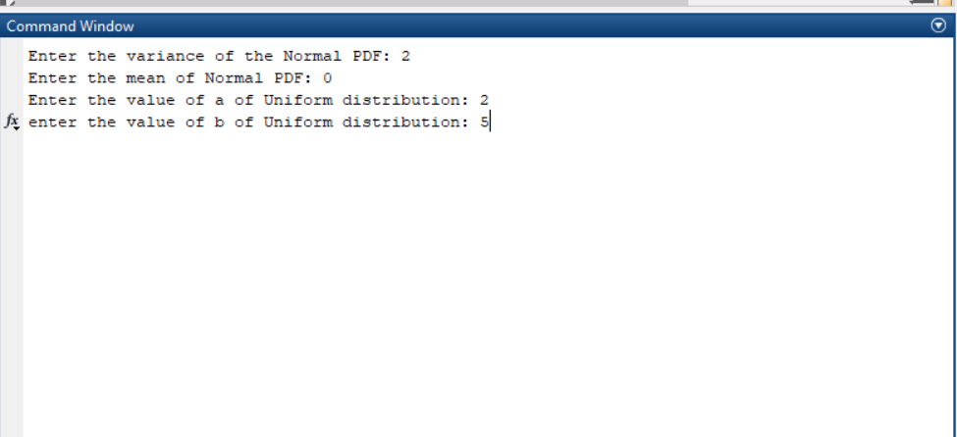

OUTPUT FOR MATLAB CODE

Gaussian CDF & PDF
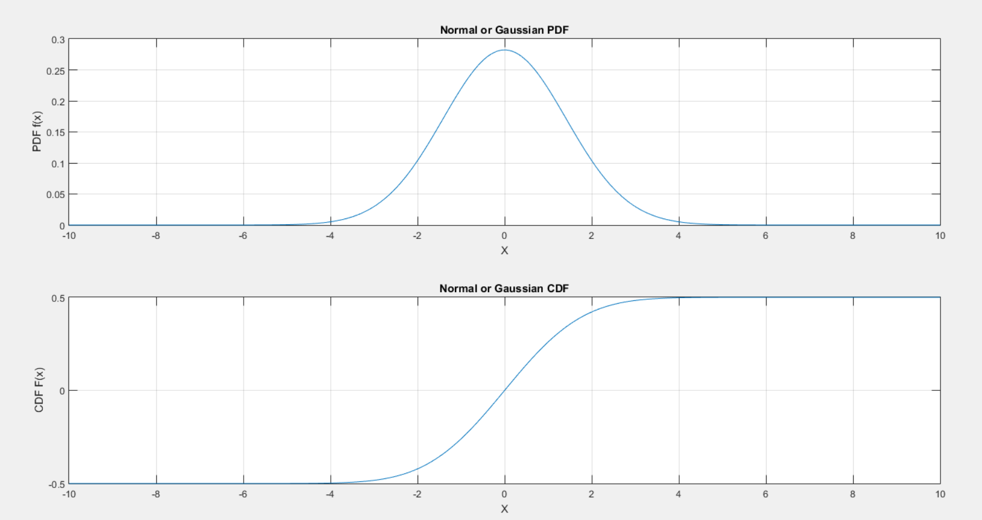

Uniform CDF & PDF
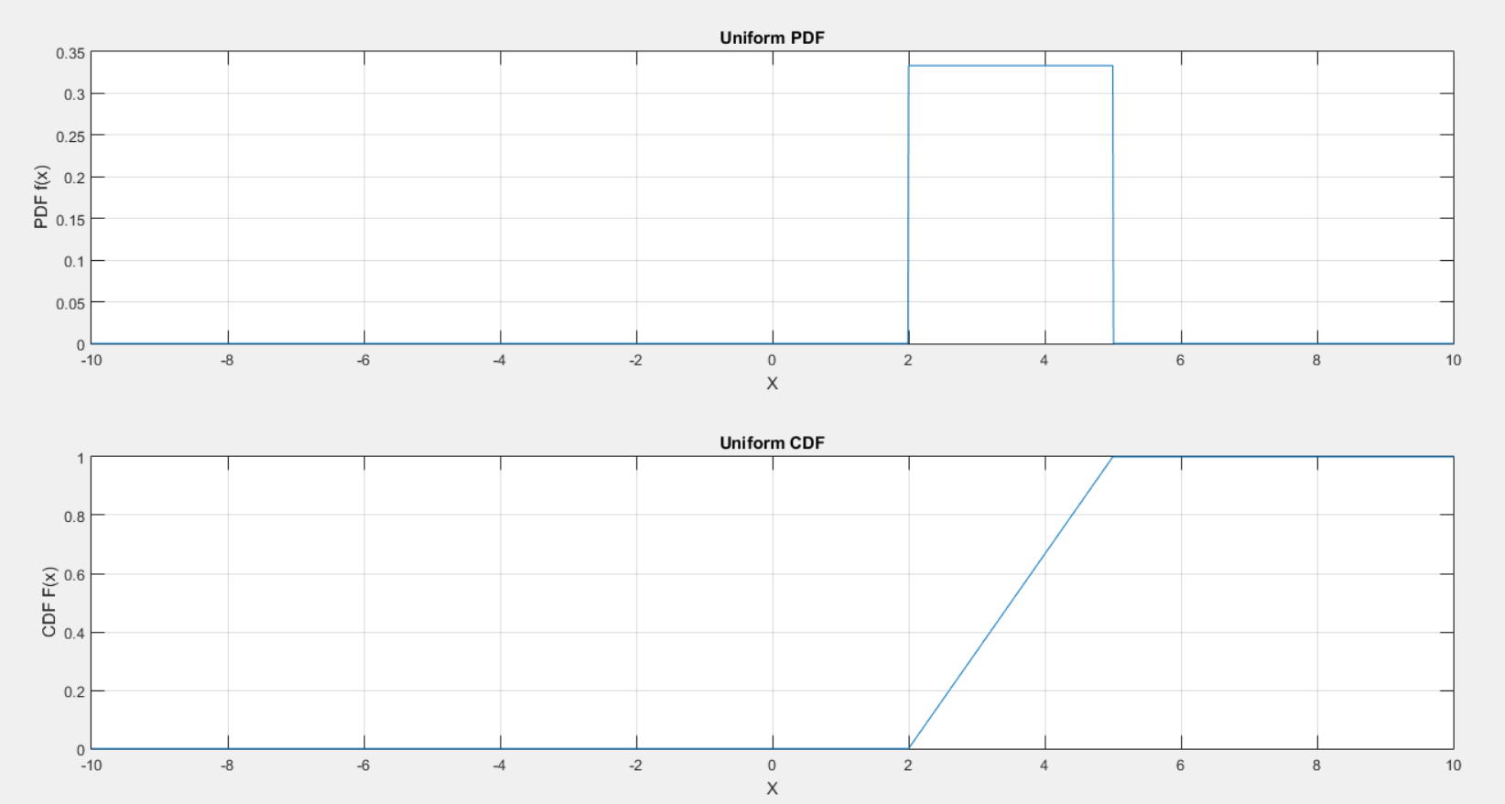

OUTPUT FOR MODIFIED MATLAB CODE
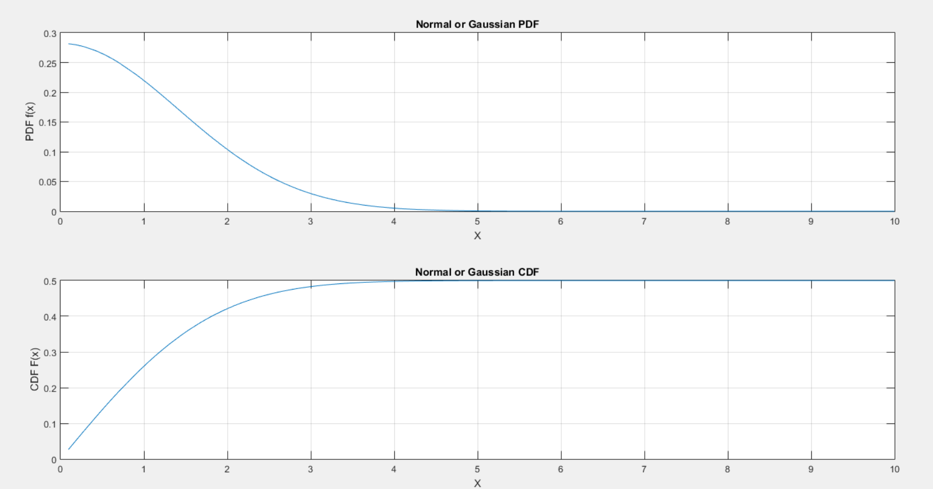

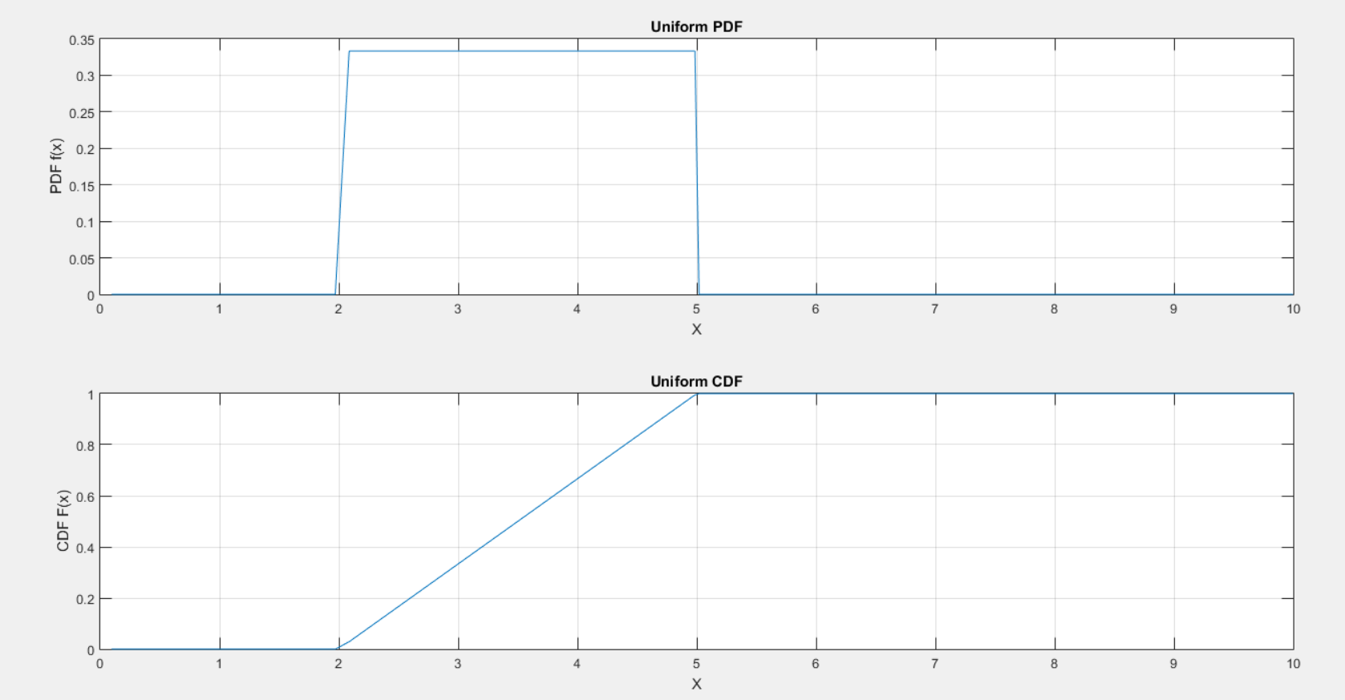

Explanation
The code accepts the input as the mean and variance of the gaussian distribution as well as the upper and lower limit of the uniform distribution(a & b). Here we have given the variance as 2 and mean at 0. The value of a is 2 & b is 5 for the uniform distribution.
The outputs are the plots of random variable PDF/CDF vs random variable X for the gaussian and uniform distributions.
In the first program, the random variable X is generated linearly from -10 to 10 with a spacing of 0.001 in between. In the modified program, rand function has been used to generate random values of the random variable between 0 to 10.
It can been seen that for Uniform PDF, the probability of random variable X when it lies in [a,b] range is constant. Hence it is called uniform. The CDF gives the cumulative probability when X<=x and hence is it a non-decreasing function. The integral of PDF gives us the CDF and the total value of CDF is unity.
In the gaussian distribution, the mean and variance determine the plot curve. Rom the plots we can see that the probability is highest at the mean value and goes on decreasing as the random variable go far away from the mean. The variance determines the width of the curve the PDF curve. The CDF is again given by the integral of the probability function and hence again gives the curve where the probability value is 0 at mean and goes on increasing as becomes 1 when it goes beyond the variance.

REFERENCES
- Zwillinger, Daniel; Kokoska, Stephen (2010). CRC Standard Probability and Statistics Tables and Formulae. CRC Press. p. 49. ISBN 978-1-58488-059-2.
- Gentle, J.E. (2009). Computational Statistics. Springer. ISBN 978-0-387-98145-1. Retrieved 2010-08-06.
- http://www.matworks.com (MATWORKS)
- https://en.wikipedia.org/ (WIKIPEDIA)

